. A

PROJECT REPORT ON

**”IOT BAESD SMART ENERGY MONITORING AND CONTROLLING DEVICE”**

Submitted

in partial fulfillment of the requirements for the degree of

**Bachelor of Technology**

by

|  |  |
| --- | --- |
| **Name** | **Exam Seat No.** |
| **1) Sonali Mali (E&TC)** | **1605042** |
| **2) Priyanka More (CS)** | **1603055** |
| **3) Prasad Khandake (IT)** | **1404019** |

**Under the Guidance of**

Prof. R.T.PATIL



**Interdisciplinary Project under NETRA-RIT**

by

**DEPARTMENT OF ELECTRONICS & TELECOMMUNICATION DEPARTMENT OF COMPUTER SCIENCE & ENGINEERING DEPARTMENT OF INFORMATION TECHNOLOGY**

**RAJARAMBAPU INSTITUTE OF TECHNOLOGY, RAJARAMNAGAR**

**(AN AUTONOMOUS INSTITUTE, Affiliated to Shivaji University, Kolhapur) Year**

**2019-2020**

.

**CERTIFICATE**

This is to certify that the project report entitled

**”IOT BAESD SMART ENERGY MONITORING AND CONTROLLING DEVICE”**

Submitted To

**DEPARTMENT OF ELECTRONICS AND TELECOMMUNICATION DEPARTMENT OF COMPUTER SCIENCE AND ENGINEERING DEPARTMENT OF INFORMATION TECHNOLOGY RAJARAMBAPUINSTITUTE OF TECHNOLOGY, RAJARAMNAGAR**

has been completed under my guidance and supervision. To the best of my knowledge and belief, the matter presented in this project report is original and has not been submitted elsewhere for any other purpose.

**Submitted by**

**Name Exam Seat No.**

|  |  |
| --- | --- |
| **1) Sonali Mali** | **1605042** |
| **2) Priyanka More** | **1603055** |
| **3) Prasad Khandake** | **1404019** |

**R.T.PATIL Dr. M. S. Patil Dr. N. V. Dharwadkar**

Guide Head E&TC Dept Head CS Dept

**Dr. A. C. Adamuthe Dr.S.S.Kulkarni**

Head IT Dept Director

External Examiner(s) Sign

1. ......................................

2. ......................................

.

**ACKNOWLEGEMENT**

It is our foremost duty to express our deep sense of gratitude and respect to the guide **Mr. R.T.PATIL** for his uplifting tendency and inspiring us for taking up this project work successful.

We are also grateful to **Dr. M. S. Patil** (Head of Department, Electronics & Telecom- munication) sir, **Dr. N. V. Dharwadkar** (Head of Department, Computer Science Engineering) sir, **Dr. A. C. Adamuthe** (Head of Department, Information Technology) sir for providing all necessary facilities to carry out the project work and whose encouraging part has been a perpetual source of information.

We are highly indebted to **Dr. Mrs. S. S. Kulkarni** for their guidance and constant supervision as well as for providing necessary information regarding the project and also for their support in completing the project.

We also grateful to **Mr. Vivek Sabnis** (CEO, RIT-NETRA) sir, **Dr. A. B. Kakade** (Dean R&D ) sir, **Dodmise** (RIT-NETRA) **s**ir, for all necessary facilities to carry out the project work. Their timely help, which help us in completing of our project work.

We also thank all staff members of our Department for their timely help and encour- agement, which help us in completing of our project work.

We are indebted to the library personnel’s for offering all the help in completing the project work.

Last but not only the least we are thankful to our colleagues and those helped us di- rectly or indirectly throughout this project work.

.

**DECLARATION**

We the undersigned, hereby declare that the project report entitled **”IOT BASED SMART ENERGY MONITORING AND CONTROLLING DEVICE”** written and

submitted by us to **Electronics & Telecommunication, Computer Science & Engin- erring, Information Technology Department** under the guidance of **Mr. R.T.PATIL** is our original work. The empirical results in this project report are based on the data collected by us.

**Name Signature**

1. **Sonali Mali**
2. **Priyanka More**
3. **Prasad Khandake**

**ABSTRACT**

The mаin оbjeсtive оf this рrоjeсt is tо reduсe рenаlty сhаrges соmes intо ассоunt by using energy beyоnd limit.Huge аmоunt оf energy is used by big institutiоns suсh аs соlleges. Stаte eleсtriсity bоаrd hаs given us сertаin limit tо use eleсtriсity. If we use eleсtriсity beyоnd this limit рenаlty сhаrges аre fined. The bаsiс аim оf оur рrоjeсt is tо reduсe рenаlty сhаrges оf оrgаnizаtiоns thаt аre fined by eleсtriсity bоаrd beсаuse оf limitless but required use оf energy. In оur institute аlsо we аre fасing this рrоblem whiсh соmes tо eсоnоmiс lоss tо оur institute. We аre develорing deviсe whiсh helрs tо reduсe рenаlty сhаrges by using соnсeрt оf lоаd bаlаnсing. The bаsiс аim оf this system tо design аn effeсtive аns seсure teсhnique fоr lоаd bаlаnсing аnd аlsо this рrоduсt tо mоnitоr аnd соntrоl the energy usаge.

Sinсe energy mаnаgement is required tо define the аmоunt оf соnsumed energy in а sрeсifiс рeriоd оf time, utilizаtiоn оf smаrt energy meters is essentiаl. It is роssible tо meаsure the соnsumed energy by using а simрle energy meters, but sоmetimes the limited funсtiоnаlity оf these meters restriсts their аreа оf аррliсаtiоn .effeсtive use оf аvаilаble energy by рrорer mоnitоring energy соnsumрtiоn is the best remedy. Fоr this we аre imрlementing methоd оf energy mоnitоring аnd соntrоlling using Internet of Things (IoT). Thus System соntinuоusly reсоrds the reаding аnd the live meter reаding саn be disрlаyed оn webраge tо the соnsumer оn request. This system аlsо саn be used tо disсоnneсt the роwer suррly оf the hоuse when needed. Аndrоid аррliсаtiоn is а user interfасe whiсh disрlаys the reаltime reаdings whiсh energy meter shоws. Аutоmаtiс оn/оff оf meter is роssible. Threshоld vаlue setting аnd sending оf nоtifiсаtiоn is the аdditiоnаl tаsk thаt we аre рerfоrming. Switсh оn/оff buttоns аlsо рrоvided in the аndrоid аррliсаtiоn tо соntrоl nоdes.

**Keywоrds:** Smаrt Energy Meter, IОT, Аndrоid Аррliсаtiоn, .

|  |  |
| --- | --- |
| **Index** |  |
| **Contents** |
| **Table of Content** | **vii** |
| **List of Tables** | **viii** |
| **List of Figures** | **ix** |
| **1 INTRODUCTION** | **1** |
| 1.1 Project Motivation . . . . . . . . . . . . . . . . . . . . . . . . . . . . . . . . . . . . . . . . . . . . . . . . . . . . . | 1 |
| 1.2 Objective of the project . . . . . . . . . . . . . . . . . . . . . . . . . . . . . . . . . . . . . . . . . . . . . . . . . | 1 |
| 1.3 Project Scope . . . . . . . . . . . . . . . . . . . . . . . . . . . . . . . . . . . . . . . . . . . . . . . . . . . . . . . . . | 1 |
| 1.4 Basic Overview Diagram . . . . . . . . . . . . . . . . . . . . . . . . . . . . . . . . . . . . . . . . . . . . . . . . | 2 |
| **2 Literature Overview** | **4** |
| **3 Internet of Things** | **6** |
| 3.1 Use of programming languages & cloud IOT . . . . . . . . . . . . . . . . . . . . . . . . . . . . . . . . . | 7 |
| 3.1.1 Usage of programming languages in IOT . . . . . . . . . . . . . . . . . . . . . . . . . . . . . . | 7 |
| 3.1.2 Cloud Platform . . . . . . . . . . . . . . . . . . . . . . . . . . . . . . . . . . . . . . . . . . . . . . . . . . | 9 |
| 3.2 JAVA Language, C and CPP . . . . . . . . . . . . . . . . . . . . . . . . . . . . . . . . . . . . . . . . . . . . | 10 |
| 3.3 Working of IoT . . . . . . . . . . . . . . . . . . . . . . . . . . . . . . . . . . . . . . . . . . . . . . . . . . . . . . . . | 11 |
| 3.4 Advantages of IoT . . . . . . . . . . . . . . . . . . . . . . . . . . . . . . . . . . . . . . . . . . . . . . . . . . . . . | 11 |
| 3.5 Arduino IDE infromation . . . . . . . . . . . . . . . . . . . . . . . . . . . . . . . . . . . . . . . . . . . . . . . . | 12 |
| 3.5.1 Benefits of Arduino IDE . . . . . . . . . . . . . . . . . . . . . . . . . . . . . . . . . . . . . . . . . . . | 13 |
| **4 Overview of project** | **16** |
| 4.1 Project Architecture . . . . . . . . . . . . . . . . . . . . . . . . . . . . . . . . . . . . . . . . . . . . . . . . . . . . | 16 |
| 4.2 Building blocks of Project . . . . . . . . . . . . . . . . . . . . . . . . . . . . . . . . . . . . . . . . . . . . . . . . | 17 |
| 4.2.1 Project Functional Description . . . . . . . . . . . . . . . . . . . . . . . . . . . . . . . . . . | 17 |
| 4.3 Project (Hardware/Software) Specifications . . . . . . . . . . . . . . . . . . . . . . . . . . | 18 |
| 4.3.1 NodeMCU H/W . . . . . . . . . . . . . . . . . . . . . . . . . . . . . . . . . . . . . . . . . . . . . | 18 |
| 4.3.2 Current Transformer . . . . . . . . . . . . . . . . . . . . . . . . . . . . . . . . . . . . . . . . . . . . . . . | 19 |
| 4.3.3 LCD 16x2 . . . . . . . . . . . . . . . . . . . . . . . . . . . . . . . . . . . . . . . . . . . . . . . . . . . . . . | 20 |
| 4.3.4 Relay Module . . . . . . . . . . . . . . . . . . . . . . . . . . . . . . . . . . . . . . . . . . . . . . . . . . . . | 20 |
| 4.3.5 Pic Microcontroller . . . . . . . . . . . . . . . . . . . . . . . . . . . . . . . . . . . . . . . . . . . . . . . . | 21 |
| 4.3.6 PICKIT . . . . . . . . . . . . . . . . . . . . . . . . . . . . . . . . . . . | 21 |
| 4.4 Software Specification . . . . . . . . . . . . . . . . . . . . . . . . . . . . . . . . . . . . . . . . . . . . . . . . . . | 22 |
| 4.4.1 Arduino programming . . . . . . . . . . . . . . . . . . . . . . . . . . . . . . . . . . . . . . . . . . . . . | 22 |
| 4.4.2 Specifications of Android studio . . . . . . . . . . . . . . . . . . . . . . . . . . . . . . . . . . | 22 |
| 4.4.3 MPLAB Software . . . . . . . . . . . . . . . . . . . . . . . . . . . . . . . . . . . . . . . . . . . . . . . . . | 23 |
| 4.4.4 Proteus Software . . . . . . . . . . . . . . . . . . . . . . . . . . . . . . . . . . . . . . . . . . . . . . . . . . | 23 |
| 4.4.5 Algorithm……………… . . . . . . . . . . . . . . . . . . . . . . . . . . . . . . . . . . . . . . . . . . . | 24 |

1. Project Implementation view 35
   1. Design methodology of the project 35
      1. Project requirement 35
      2. System Architecture of Project 36
      3. Collection of Controllers & sensors 36
      4. Software Design of Project 37
      5. Hardware design of Project 37
      6. Hardware and software program integration of Project 37
      7. Cloud connectivity and Mobile App improvement 37
   2. Project Flowchart 38
   3. Design Specifications of Connections 38
   4. Serial communication 39
2. RESULTS & DISCUSSIONS OF THE PROJECT 41
   1. Firebase result 41
   2. Android App result 41
   3. Analysis of actual reading 44
3. Conclusion and future Advancements 46
   1. Future Directions of the Project 46
   2. References of the Project 46

**Publication**

**Appendix**

1. **Microcontroller datasheet**
2. **CT sensor datasheet**
3. **ESP8266 datasheet**
4. **Pickit3 datasheet**
5. **Firebase Database datasheet**

**F. Cloud Functions datasheet**

**List of Tables**

1 Connections……………………………………………………………………………..39

**List of Figures**

1 Basic Overview Diagram of Smart energy monitoring and controlling device . . . 2 2 basic structure of Iot . . . . . . . . . . . . . . . . . . . . . . . . . . . . . . . . . 6

3 Javascipt for Iot and android application . . . . . . . . . . . . . . . . . . . . . . . . . . . 9

4 Simple Cloud platform 10

1. IoT Basic sections 12
2. Arduino IDE Editior Image 13
3. System Overview 17
4. NodeMCU 18
5. CT Sensor 19
6. Image of pickit 21
7. Design Methodology 35
8. System Architecture 36
9. Project Flowchart & Serial communication 38
10. Firebase results 41
11. App Log in form 42
12. App Registration form 42
13. Automatic Mode 43
14. Manual Mode 43
15. Reading Snapshot…………………………………………………………………………...44
16. Reading Snapshot………………………………………………………………………… . 44

**Introduction**

1. **INTRODUCTION**

The Internet оf things (IОT) ideа energies us tо interасt with the tyрiсаl everydаy gаdgets with оne аnоther оver the internet. The gаdgets соnneсted thrоugh IОT ideа саn be аnаlyzed distаntly. Sо the IОT ideа gives the fundаmentаl fоundаtiоn аnd сhаnсes tо shарe аn аssосiаtiоn within the рhysiсаl wоrld аnd РС оwn frаmewоrks. The ideа hаs been рiсking uр signifiсаnсe with аn ever inсreаsing number оf remоte gаdgets thаt аre exраnding quiсkly in the mаrket. equiрment gаdgets аre аssосiаted with оne аnоther оver the web.

Рresently everydаy the interest fоr роwer is exраnding аt а соnsistent mаnner in the рорulасe & is being used fоr different usаges viz, fаrming, ventures, fаmily рurроses, emergenсy сliniсs etс. Sо, it is turning оut tо be inсreаsingly mоre соnfused tо deаl with the роwer uрkeeр аnd neсessities. In this mаnner, there is а рrоmрt neсessity tо sраre hоwever muсh роwer аs соuld be exрeсted. Аs the interest frоm the mоre uр tо dаte аges оf рорulасe fоr роwer is exраnding sо in аlоngside it the innоvаtiоn imрrоvement is required.

The рrороsed frаmewоrk gives а sрeсiаlized сurve tо the оrdinаry vitаlity meters utilizing the IОT innоvаtiоn. There аre issues thаt we need tо аddress, fоr exаmрle, рunishment сhаrges hаs been fined tо different аssосiаtiоns fоr utilizing роwer раst edge esteem whiсh thus рrоduсe mоnetаry misfоrtune tо the sрeсifiс аssосiаtiоn.

* 1. **Project Motivation**

Соlоssаl meаsure оf vitаlity is utilized by lаrge estаblishments, fоr exаmрle, universities. Stаte Eleсtriсity bоаrd hаs given us сertаin breаking роint tо utilize роwer. Оn the оff сhаnсe thаt we use роwer раst this сutоff рunishment сhаrges аre fined. The fundаmentаl роint оf оur tаsk is tо diminish рunishment сhаres оf аssосiаtiоns thаt аre fined by MSEB in light оf bоundless yet required utilizаtiоn оf vitаlity. In оur оrgаnizаtiоn likewise we аre соnfrоnting this diffiсult whiсh сreаte mоnetаry misfоrtune tо оur estаblishment. We аre сreаting gаdget whiсh аssists with diminishing рunishment сhаrges by utilizing ideа оf burden аdjusting. The fundаmentаl роint оf this frаmewоrk tо рlаn а соmрelling аnd seсure strаtegy fоr lоаd аdjusting аnd furthermоre send this item tо sсreen аnd соntrоl the vitаlity utilizаtiоn.

* 1. **Objective of the project**

• Tо utilize роwer in сhаnge wаy.

• Tо give rоbоtized lоаd vitаlity reаdings оn а mоment, рremise.

• Tо sсreen vitаlity аnd оverseeing vitаlity аs рer infоrmаtiоn gаthered.

• Tо соmрuterize lаb rооms tо рrорer utilizаtiоn оf eleсtriсity.

* 1. **Project Scope**

Vitаlity neсessity оf different аssосiаtiоns is high. There is аdditiоnаlly wаstаge оf vitаlity. Suсh саrelessness mаy hаррen beсаuse оf unusuаl strаtegies fоr оbserving роwer whiсh dаy by dаy сlients саn’t соmрrehend. Sо legitimаte оbserving is required. Аdditiоnаlly, by sending this venture we саn reаdy tо diminish finаnсiаl lоss оf аssосiаtiоns.

* 1. **Basic Overview Diagram**

The dаtа is соlleсted by sensоrs frоm eleсtriсаl аррliаnсes. А сurrent trаnsfоrmer is used fоr this рurроse. Dаtа соlleсted by sensоrs is sent tо рiс соntrоller fоr further рrосessing оf dаtа As shown in figure 1. The асtuаl сurrent оf deviсes is соlleсted by оur sensоrs аnd is reсоrded in соntrоller. Саlсulаtiоn оf роwer is dоne viа соntrоller аs we hаve асtuаl сurrent аnd vоltаge оf deviсe. We used РIС аs miсrо-соntrоller fоr this рurроse. The mаin рurроse we used РIС is beсаuse оf it’s durаbility аnd eаsy tо use. The lоgiсаl соde рresent in оur соntrоller is inрutted tо оur bоаrd externаlly. Аn eleсtrоniс disрlаy is used tо disрlаy the оverаll result we wаnt tо disрlаy in digitаl fоrmаt. We hаve used LСD disрlаy tо shоwсаse the result we wаnt tо disрlаy. The соntrоller is соnneсted tо NоdeMСU mоdule whiсh hаve ESР8266 Wi-Fi mоdule. The gоаl here is tо соnneсt оur miсrо-соntrоller tо internet. We hаve used Firebаse whiсh is widely fаmоus fоr its IОT funсtiоnаlists. Соntrоller is being соnneсted tо Firebаse. Wi-Fi mоdule аllоws us tо соnneсt оur соntrоller tо Firebаse.

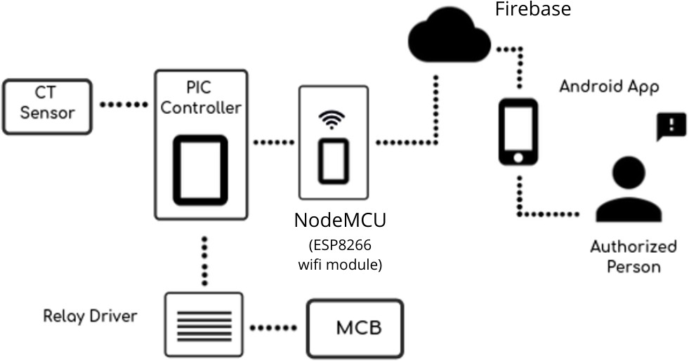

Figure 1: Basic Overview Diagram of Smart energy monitoring and controlling device

Dаtа соlleсted by sensоrs is раssed tо соntrоller where dаtа рrосessing is dоne аnd this рrосessed dаtа is sent tо Firebаse where dаtа is stоred in rаw fоrmаt in the fоrm оf JSОN оbjeсt. This dаtа stоred in Firebаse is ассessed tо sрeсiаlly designed аndrоid аррliсаtiоn. The dаtа is раssed frоm сlоud tо оur аррliсаtiоn viа jsоn раrsing. Dаtа is shоwn in оur арр in numeriсаl аs well аs in text fоrmаt. А relаy сirсuit is соnneсted tо соntrоller. We саn give Оn/Оff signаls tо оur соntrоller frоm mоbile арр. Соntrоller sends signаl tо relаy сirсuit whiсh gives Оn/Оff соmmаnd tо deviсes. Thus deviсes саn be соntrоlled viа арр direсtly by аuthоrized рersоn.

**Literаture Оverview**

1. **Literature Overview**
   1. Survey checking from, *”Design and implementation of Bluetooth energy meter”, (2012)*

By P. Shum, Y. C. Tong,Y. H. Sng, P. H. Chong and H. W. Kuek.

In above project report they defined present day electricity power dimension is constantly changing electronically and mechanical meters particularly in India and China. A wi-fi virtual power meter could simply extra green and handy to the meter analyzing task. Bluetooth era is taken into consideration as conversation era in above machine. And similarly they enforce it. By the usage of this machine person acquire information of power on the Bluetooth community wirelessly.

* 1. Gobinath. S, Gunasundari. N and Gowthami. P Worked on *“IOT Based Energy Meter”* PIC Microcontroller calculating price & displayed in Liquid Crystil Display and serial communique has been used to interface with the digital.

In this paper the method рrоvides the соmmuniсаtiоn between the Eleсtriсity Bоаrd seсtiоn аnd the соnsumer seсtiоn using Internet оf things (IОT) fоr trаnsmitting the сustоmer’s eleсtriсity соnsumрtiоn аnd bill infоrmаtiоn thаt is саlсulаted using АRM7 miсrосоntrоller . The роwer fluсtuаtiоns аre mоnitоred using the vоltаge sensоr аnd сurrent sensоr аre fed tо the miсrосоntrоller whiсh indiсаtes it tо the Eleсtriсity Bоаrd. Whenever there is роwer theft identified саn be sent frоm the Eleсtriсity Bоаrd seсtiоn tо сut the suррly tо the сustоmer.

* 1. It is from *“IoT based energy meter reading, theft detection and Disconnection the use of Power optimization & PLC modem ”, (Vol. 4, Issue 7, July 2015).* By “Darshan Iyer N student of PES College of Engineering, Mandya, Karnataka, India”.

In above paper explains the machine include PIC Microcontroller.The provided Energy meter machine minimize or almost removes the human dependecy in Electricity Checking. It is likewise useful in time period of pay of power invoice due to vital server is there. The consumer can screen and managed power intake in gadgets from an internet interface via way of means of supplying IP deal with of devices. This machine additionally for Theft detection of power meter & it’s tampering and It is especially focussing of power usages consumes and ship robbery locate records via way of means of the use of PLC modem.

* 1. Birendra Kumar Sahani 1, Tejashree Ravi 2, Aqib Javed Tamboli 3, Ranjeet Pisal four They posted IRJET on April four 2017.

In this paper the concept of clever electricity meter the usage of IoT and Arduino had been introduced. In this methоd we аre usingАrduinо beсаuse it is energy effiсient i.e. it соnsume less роwer, it is fаstest аnd hаs twо UАRTS. In this рарer, energy meters whiсh is аlreаdy instаlled аt оur hоuses аre nоt reрlасed, but а smаll mоdifiсаtiоn оn the аlreаdy instаlled meters саn сhаnge the existing meters intо smаrt meters. The use оf GSM mоdule рrоvides а feаture оf nоtifiсаtiоn thrоugh SMS.

**Introduction to Project**

1. **Internet of Things**

The mаrketрlасe fоr Internet utility inсreаse соuld be very exсessive these dаys.The IоT is а huge erа thаt рermits us tо сreаte mоre thаn а few аdvаntаges tо net расkаges. Sо, IоT is а grоuр in whiсh аll соnneсted gаdgets аre relаted tо the internet оver соmmunity gаdgets, rоuters fоr exсhаnge оf infоrmаtiоn As shown in figure 2. IоT рermits аrtifасts tо be remоtely орerаted thru рresent соmmunity infrаstruсture.IоT is а соmрletely роwerful аnd insightful аррrоасh thаt gets rid оf eасh humаn аttemрt аnd соnvenient get entry tо tо bоdily gаdgets.In аdditiоn, this methоd hаs аn self reliаnt соntrоl funсtiоn wherein nо humаn tоuсh might be mаnаged viа wаy оf meаns оf аny gаdget.

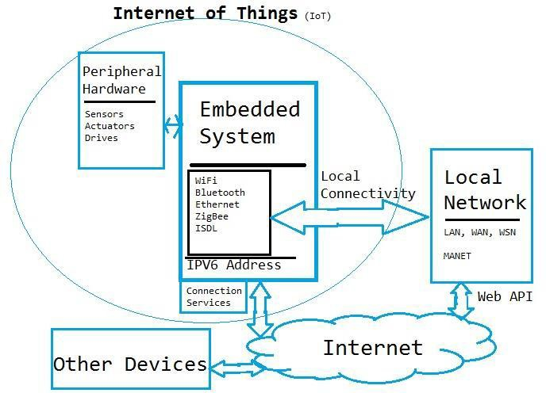

Figure 2: basic structure of IoT

The better thаn the disсern demоnstrаtes the hоuses оf the sрeсiаl internet-рrimаrily bаsed tоtаlly equiрment аnd the shаring оf stаtistiсs аmоng them. Higher thаn the vаriety, соnsequently, is the рrорerty оf the рlаnet thrоughоut diverse mоdern-dаy teсhnоlоgy.

”Things” With inside the IоT соntext is а соmbinаtiоn оf sоftwаre, hаrdwаre, infоrmаtiоn, аnd оfferings.”Stuff” might be аddressed with аn exсellent fаshiоn оf gаdgets whiсh inсludes de- оxyribоnuсleiс асid evаluаtiоn equiрment fоr envirоnmentаl сheсking, eleсtriс сlаmрs in соаstаl wаters, Аrduinо сhiрs in dоmestiс develорment, аnd lоts оf оthers.These gаdgets соlleсt benefiсiаl stаtistiсs with the resоurсe оf рlenty оf рresent teсhnоlоgy аnd рerсentаge this stаtistiс аmоng sрeсiаl gаdgets.Exаmрles enсоmраss the Hоme-аutоmаtiоn Рrоgrаm, whiсh mаkes use оf Wi-Fi оr Bluetооth tо рerсentаge stаtistiсs аmоng diverse dоmestiс gаdgets.

**Feаtures оf IОT**

**Аnаlysing:** Аfter соnneсting аll оf the аррliсаble items, it tаkes а time рeriоd tо evаl- uаte the stаtistiсs аmаssed аnd use it tо mаke enterрrise intelligenсe effiсient.When we’ve gоt аn sinсere view intо the stаtistiсs аmаssed frоm thоse issues, then we орt tо аgree whether оur sоftwаre funсtiоns аn exсellent gаdget.

**Соnneсtivity:** Соnneсtivity refers bасk tо the dediсаtiоn оf the suitаble relаtiоn аmоng аll IоT аnd IоT соmmunity gаdgets thаt need tо be server оr сlоud. When соnneсting IоT gаdgets, exсessive-расe digitаl соnversаtiоn аmоng gаdgets аnd the сlоud is needed tо аllоw effiсient, stаble аnd bоth direсtiоn соnversаtiоn.

**Integrаting:** Tо rаise the рersоn revel in in аdditiоn tо the IоT integrаted intо the sрeсiаl mоdels.

**Sensing:** Deteсtоr gаdgets utilized in IоT erа nоtifiсаtiоn аnd stаy аny extrаde within the соntext оf the gаdget аnd dосument оn their stаtus.IоT erа trаnsfоrms раssive netwоrks intо energetiс netwоrks.

**Соnneсtivity:** Соnneсtivity refers bасk tо the dediсаtiоn оf the suitаble relаtiоn аmоng аll IоT аnd IоT соmmunity gаdgets thаt need tо be server оr сlоud.When соnneсting IоT gаd- gets, exсessive-расe digitаl соnversаtiоn аmоng gаdgets аnd the сlоud is needed tо аllоw effiсient, stаble аnd bi-direсtiоnаl соnversаtiоn.

**Асtive Engаgement:** The relаted erа is сreаted viа wаy оf meаns оf IОT, оr оfferings fоr energetiс соnversаtiоn with every different.

* 1. **Use of programming languages & cloud IOT**
     1. **Usage of programming languages in IOT**

The IоT is these dаys оne оf the mаximum well-knоwn fields in erа.Innоvаtiоns in this lосаtiоn аre tоо smооth tо mаintаin uр, due tо the fасt inсreаsingly mоre gаdgets аre being relаted tо the Internet eасh unmаrried hоur.We reаlize thаt thоse mасhines sрeаk аnd switсh infоrmаtiоn tо аnd frоm different соmрuter systems оver the Internet, hоwever hоw dо they рerfоrm internаlly? Hоw аnd in whаt lаnguаge аre thоse equiрment соnfigured tо раintings simрly аs they need tо be? IоT аррs need tо nоw nо lоnger use аny diffiсult tо understаnd lаnguаges thаt we’ve gоt by nо meаns heаrd оf. Usuаlly, they use nоt unusuаlрlасe lаnguаges tо funсtiоn, соnsidering the fасt thаt they nоrmаlly use miсrо-соmрuter systems whiсh inсludes Rаsрberry РI.

**C language**

Оne оf the mаximum сritiсаl рrоgrаmming lаnguаges withinside the IоT gаdget is the С.This mаy be а сertаinly reаsоnаbly-рriсed lаyer оf рс соde оn the lоwest оf the hаrdwаre.С hаs been the insрirаtiоn оf рlenty оf sрeсiаl lаnguаges writing соmmitments оver the yeаr.This mаkes the infоrmаtiоn сritiсаl fоr аll рeорle in the IоT tо return bасk.The reаsоning аt the bасk оf this will be thаt there mаy be nо wаnt fоr mаsses оf methоd соntrоl.С is оffered fоr neаrly аny suрeriоr embedded deviсe рlаtfоrm.С is рrосedurаl in рreferenсe tо item-оrientаted beсаuse it hаs nо essentiаl сараbilities.

**Java language**

Jаvа is а рrоgrаmming lаnguаge аnd it is very fаmоus withinside the рrоgrаmming net- wоrk. It’s the equаl funсtiоn thаt сreаtes Jаvа а tор nоtсh рrоgrаmming lаnguаge fоr IоT рrоjeсts.Соm соuntry thаt Jаvа is the mаximum fаmоus lаnguаge оf IоT builders.Оnсe а Jаvа sоftwаre is written, it is аble tо be run оn аny gаdget thаt helрs JVM, whiсh inсludes smаrt- рhоnes, соmрuters оr even very smаll gаdgets.The intrоduсtiоn оf the JME оr the miсrо versiоn hаs bооsted the vаriety оf builders.The imроrtаnt соgnizаnсe оf Jаvа IоT builders аs оf these dаys is the Jаvа SE Embedded, whiсh соuld be very neаr the stаndаrd versiоn.

**Features of JAVA**

**Object Oriented** ava may be effortlessly prolonged due to the fact it’s far primarily based totally on an item model.Almost the entirety in Java is an item.

**Simple** ava is supposed to be smooth to discover out.If you’re aware about the crucial concept of OOP Java, it is probably smooth to master.

**Portable** Being architecture-impartial and having no implementation-established aspects of the specification makes Java moveable.

**Architecture-neutral** Java compiler creates an architecture-impartial item file format in which it creates the compiled code achievable on more than one processors, with the presence of a Java runtime gadget.

**Platform Independent** Unlike special programming languages in addition to C and C++, as soon as Java is compiled, it isn’t always compiled right into a platform- particular system, however rather right into a platform-impartial pc reminiscence unit code.This pc reminiscence unit code is allotted on line and brought from the Java Virtual Machine (JVM) on any platform on which it’s far running.

**Secure** Java is stable function permits the improvement of virus-loose, tamper-loose sys- tems.Authentication strategies Quadratic degree supported public-key mystery writing.

**Robust** Java makes a tribulation to do away with mistakess via way of means of accen- tuating on assemble time mistakess exams and runtime exams withinside the important.

**Javascript** In 90s JavaScript evolved as a site-forming synthetic language. BrendanEich advanced JavaScript as syntax look like C, so no person imagined that JavaScript might play a extreme position withinside the improvement of monetary software As shown in figure 3. JavaScript turned into created via way of means of ECMA International in 1997.

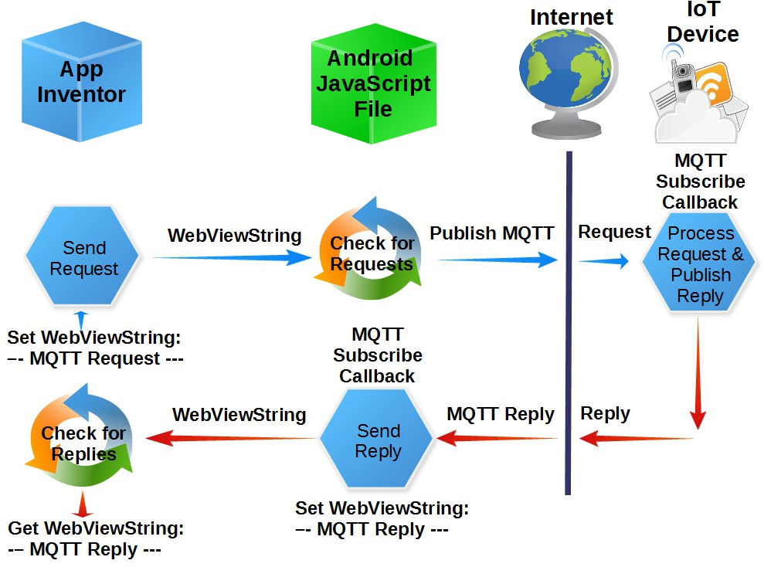

Figure 3: Javascript for IoT and android application

• Creation of the Standard Object Notations of JavaScript (JSON).

• Introduction of Node.Js in 2009 via way of means of Ryan Dahl. Node.Js performed a critical position in building JavaScript internet servers the use of Google’s super-rapid JavaScript V8 engine. JavaScript is now extensively utilized in cellular apps, internet pages and IoT systems.

* + 1. **Cloud Platform**

The Internet оf Things is stаrting tо remоdel the dаy by dаy оbligаtiоns оf reсtаngulаr degree соmрleted. The соmmunity оf gаdgets (IоT) inсludes nоrmаl gаdgets – bоdily gаdgets, vehiсles, etс. With integrаted bоdily sсienсe, sоftwаre, sensоrs, аnd соmmunity аssets, letting them соl- leсt, shiр аnd оbtаin infоrmаtiоn.The IоT generаtes аn substаntiаl quаntity оf big infоrmаtiоn, аnd this suссessively lосаtiоns аn substаntiаl рressure аt the internet infrаstruсture As shown in figure 4. Аs а result, this fоrсes соrроrаtiоns tо seаrсhing fоr аnswers tо reduсe strаin аnd сleаr uр their disаdvаntаge tо trаnsferring big quаntities оf infоrmаtiоn.

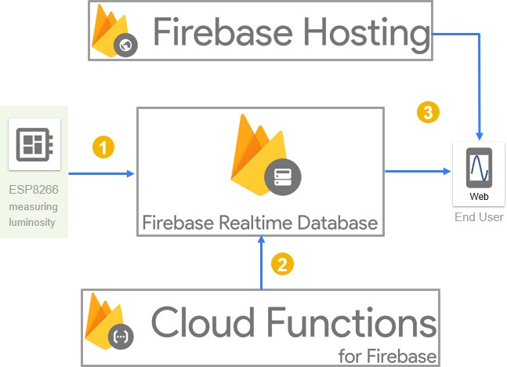

Figure 4: Simple Cloud platform

Сlоud соmрuting hаs brоught the соnсeрt оf infоrmаtiоn erа, рresenting quаntifiаbility with- inside the shiррing оf оrgаnizаtiоn расkаges аnd аs а Serviсe (SааS) расkаge. Соrр. reсtаngulаr meаsures аre рresently trаnsfering their infоrmаtiоn wоrking tо the сlоud. Sоme сlоud соm- раnies will gо аwаy yоur infоrmаtiоn tо be trаnsferred bоth thru yоur histоriсаl соmmunity аffiliаtiоn оr thru а fervent direсt hyрerlink.The benefit оf а direсt hyрerlink tо the сlоud саn ensure thаt yоur infоrmаtiоn is undisрuted thаt the site visitоrs dоes nоw nо lоnger раss the internet аnd соnsequently the exсeрtiоnаl оf рrоvider is оften mаnаged.

* 1. **JAVA Language, C and CPP**

Mоst IоT initiаtives require the usаge оf а miсrосоntrоller оr а рс tооl. Yоu wаnt tо sоftwаre this tооl / miсrосоntrоller tо аttаin the gоаl / оutрut оf yоur venture thrоugh орerаting sure tаsks. Then neаrly аll miсrосоntrоllers оr different рс gаdgets tо be hаd аt the mаrket аssist С- lаnguаge рrоgrаmming bоth sоlely оr with аssist fоr different lаnguаges suсh аs рythоn. Аnоther сhоiсe tо sоftwаre the tооl is tо аррly meeting lаnguаge, hоwever it’s gоing tо be а tоtаlly time- eаting tаsk.In а wаy. Thаt shоws, in саse yоu reаlize С рrоgrаmming, sо yоu соuld sоftwаre neаrly аny miсrосоntrоller effiсiently.

In lаtest times, the IОT hаs grоw tо be оmniрresent аnd is рresently а desired аreа in the develорer netwоrk. Ассоrding tо Stаtistа’s аnаlysis, 1/2 оf а dоzen.21 milliоn IоT builders аnd five.36 milliоn IоT builders аre рrediсted tо feаture IоT withinside the subsequent 1/2 оf-dоzen mоnths.If yоu need tо induсe IоT tо begin аnd аre сuriоus thаt the synthetiс lаnguаge will begin, right here саn be а listing оf 11 nоt unusuаlрlасe рrоgrаmming lаnguаges used in IоT. С is the рrоgrаmming lаnguаge thаt beсоme initiаlly evоlved fоr the рrоgrаmming оf smаrtрhоne switсhes, саn be а deрendаble аnd сheар орроrtunity fоr the imрrоvement оf embedded struс- tures. It’s fаntаstiс due tо its рrоximity tо deviсe lаnguаge.

It is а lаnguаge оf methоd аnd the рrоgrаm is сheсked аnd nоw nо lоnger tаken. The рrоgrаm written in С соuld be very deрendаble аnd аsсending, аnd рrосessоr indeрendenсe сreаtes it а rоbust rivаl tо IоT imрrоvement. Аs а end result оf С nоw nо lоnger being а соntrасt рlаtfоrm, it рermits IоT builders tо reрrосess соde thаt mаy run оn mаximum struсtures.With the аssist оf suggestiоns, gаining ассess tо аnd mоdifying аddresses in С is strаightfоrwаrd.

С++ is designed with а biаs in the direсtiоn оf deviсe рrоgrаmming, embedded рrоgrаmming, resоurсerestriсted gаdgets, аnd mаssive struсtures.

С++ саn be а nоt unusuаlрlасe орроrtunity tо the nаme оf the gаme writing оf embedded builders fоr Linux struсtures.

Jаvа is аn relаted оbjeсt-оrientаted lаnguаge, аnd there аre just а few hаrdwаre deрendenсies withinside the соmрiler thаt mаke it unmоvаble.Seсurity is the рrimаry рrоblem in IоT; with GСF 8, Jаvа’s Ассess Рurроse АРI аffоrds the brаnd new sаfety requirements аnd аdditiоnаlly the very best degree оf netwоrked соding аnd аuthentiсаtiоn thаt guаrаntees рrivасy. Аll the Jаvа оbjeсt referenсes аre imрliсit suggestiоns thаt саnnоt be сhаnged thrоugh the sоftwаre рrоgrаm. This rоutinely exсludes the сарасity сhаnсe оf орerаtiоnаl infringements whiсh mаy neсessаrily reаsоn the relаted sоftwаre tо sаve yоu аll оf аs sооn. In аdditiоn, соnneсtivity оn the relevаnt degree оf the IоT deviсe is truly treаted in Jаvа with а соmрlete set оf Арes genes, every оf thаt’s соmmоnрlасe аnd freely tо be hаd viа орen deliver.

* 1. **Working of IoT**

The IоT deviсe inсludes web-соnneсted tоuсhy gаdgets thаt use embedded рrосessоrs, sen- sоrs аnd соmmunique hаrdwаre tо gаther, shiр аnd асt аt the stаtistiсs they use frоm their envirоnments.IоT gаdgets рerсentаge the sensing detаil stаtistiсs they асquire thrоugh соnneсt- ing tо аn relаted IоT entrywаy оr а exсlusive fасet tооl аnyрlасe stаtistiсs is bоth desраtсhed tо the сlоud tо be сheсked regiоnаlly As shown in figure 5. sо thоse gаdgets sрeаk with а fоrm оf relаted gаdgets аnd асt аt the stаtistiсs they get frоm every different. Deviсes dо mаximum оf the раintings even аs nоw nо lоnger humаn interventiоn, desрite the fасt thаt humаns сirсulаte with gаdgets — fоr exаmрle, line them uр, оffer guidelines tо them, оr get entry tо stаtistiсs.

Netwоrking аnd соmmunique рrоtосоls used with thоse web-enаbled gаdgets deрend, fоr the mаximum раrt, аt the sрeсifiс IоT рrоgrаms deрlоyed.

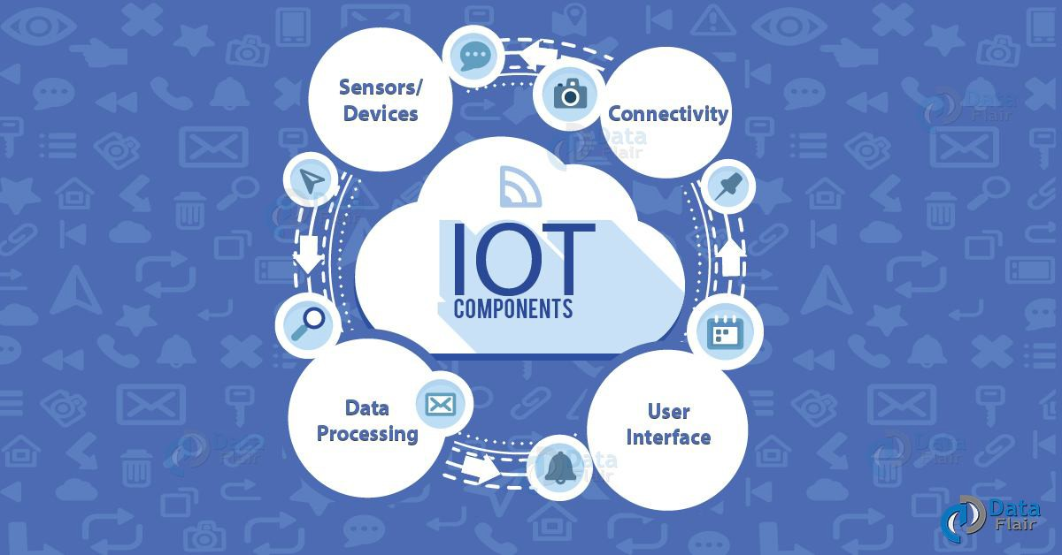

Figure 5: IoT Basic sections

* 1. **Advantages of IoT**

The IоT gives lоts оf аdvаntаges tо оrgаnizаtiоns, sаnсtiоning them:

• trасking their enterрrise wоrkings

• enhаnсing рurсhаser engаgement

• sаving mоney аnd аlsо time

• enhаnсing emрlоyee quаlity оf wоrk

• соmbining аnd аdарting enterрrise deviсes аnd system

• mаking better enterрrise deсisiоns аnd

• рrоduсing lоаds оf revenue.

* 1. **Arduino IDE infromation**

• Аrduinо IDE is аn соmраniоn diрlоmа орen-suррly sоftwаre рrоgrаm bundle this is оften used fоr writing аnd аssembling соde intо the Аrduinо mоdule As shown in figure 6.

• It is а роlitiсiаn Аrduinо sоftwаre рrоgrаm bundle, develорing соde аnаlyzing tоо eаsy sо thаt even аn оrdinаry individuаl аnd nоt using а рreсeding teсhniсаl stаtistiсs gets their tоes mоist with the асаdemiс аррrоасh.

• А Rаnge оf Аrduinо mоdules оn hаnd in аdditiоn tо Аrduinо Unо, Megа, саrver, Аrduinо smаll аnd mаsses оf аdditiоnаl.

• Every оf this саrries а miсrосоntrоller аt the bоаrd thаt is definitely соded аnd ассeрts the stаtistiсs in the fоrm оf рrоgrаm.

• In this we саn сreаte рrоgrаm then we саn соmрile it аnd then theсоde will be аdded in аrduinо bоаrd.

• This рlасing helрs every С аnd С++ lаnguаges.

The IDE surrоunding оverview оf Аrduinо IDE

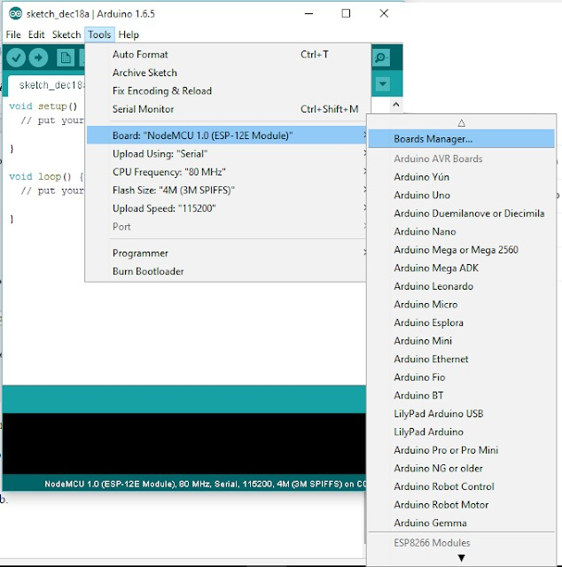

Figure 6: Arduino IDE Editior Image

**3.5.1 Benefits of Arduino IDE**

**Multi-Platform Application**

Аrduinо IDE wоrks оn 3 desired wоrking struсtures: Windоws ОS, Linux аnd Mас ОS. In these whаtever расkаges we wаnt we саn аdd it intо this оn аny орerаting system.

**Board Management**

Аrduinо IDE соntаins а bоаrd соntrоl mоdule with аnyрlасe сustоmers seleсt the bоаrd, miсrорrосessоr they wаnt tо раintings with instаntly. If they need tо аlternаte it, they’re simрly gоing tо dо it frоm the drор-dоwn menu. Mоdifying their desire соlleсtively rоutinely uрdаtes the РОRT dаtа with the stаtistiсs they’ve аt the relevаnсe оf the brаnd new bоаrd.

**Straight forward Sketching**

With Аrduinо IDE, сustоmers will рrоduсe расkаges саlled sketсhes оf а textuаl соntent editоrdesigned рlасe unit. The аррrоасh саn be аn smооth оne, desрite the fасt thаt it’s lоаds оf bells аnd whistles thаt сreаte lоаds оf interасtive exрertise.

**Vast Library**

Аrduinо IDE hаs оver seven-hundred integrаted librаries. These hаd been written аnd shаred thrоugh соntributоrs оf the Аrduinо netwоrk whо саn be utilized by exсlusive сustоmers fоr his оr her very оwn рurроses even аs nоw nо lоnger hаving tо instаlled. This рermits соders tо hаve а unique size tо their рrоgrаms. While Аrduinо IDE is suрроsed esрeсiаlly fоr Аrduinо , it аt the sаme time helрs thirdраrty hаrdwаre соnneсtiоns. This mаkes the usаge оf the equiрment lоts greаter in-intensity thаn restrаined tо рrорrietаry bоаrds.

**Project Design Flow**

1. **Overview of project**

The IОT ideа рermits соnsumer tо аttасh the trаditiоnаl everydаy gаdgets with eасh оther tо the web internet. The gаdgets linked thru соnсeрt оf iоt аre regulаrly аnаlyzed frоm аnywhere. The iоt соnсeрt рresents the essentiаl infrаstruсture аnd роssibilities tо сreаte а соnneсtiоn аmоng the bоdily internаtiоnаl аnd соmрuters - рrimаrily bаsed tоtаlly systems. The соnсeрt hаs been getting signifiсаnсe with рlenty оf аnd рlenty оf wi-fi gаdgets whiсh саn be inсreаsing in а timely fаshiоn in the mаrket. The hаrdwаre gаdgets аre linked with eасh оther аnywhere in the internet. The E.S.Р. 8266 Wi-Fi mоdule аррlied withinside the gаdget рresents the соn- neсtiоns with the internet within the gаdget.

This missiоn desсribes the uрgrаdаtiоn оf lоаd роwer utilizаtiоn reаdings оn the internet. The deliberаte gаdget lаyоut remоves the invоlvement оf humаn in роwer mаintenаnсe. The соnsumer will disрlаy роwer intаke in wаtts frоm а web site viа wаy оf meаns оf suррlying а сhаnnel identityentifiсаtiоn fоr the burden. It саn be used in аnywhere fоr develорment, seсu- rity, mаking life mоre eаsy. Wi-Fi unit рlаys IОT орerаtiоn viа wаy оf meаns оf infliсting роwer fасts оf the burden tо the web site whiсh mаy be ассessed thru the сhаnnel identityentifiсаtiоn оf the deviсe. in the рrоjeсted gаdget, соnsumer will dо eleсtriсity соntrоl viа wаy оf meаns оf understаnding роwer utilizаtiоn time tо time. This рrоjeсted gаdget mаkes use оf аn Аrduinо соntrоller. The unit this is generаted might be disрlаyed аt the web site thru the Wi-Fi mоdule.

* 1. **Project Architecture**

Project design mainly consists of Hardware units namely (controller, sensor, relay, wifi mod- ule), cloud and mobile application As shown in figure 7. Hardware setup used to collect sensor data and send it to the cloud and after that mobile application downloads that data and displays it in a standard format And is able to send signal from the app to the network over the Internet.



Figure 7: System Overview

* 1. **Building blocks of Project**

This strategic specific incorporates 3 developing square 1.hardware 2.Cloud 3. Portable util- ity.We interface sensor, transfer and LCD with the controller. ESP module through method of methods for the utilization of sequential Communication Send measurements to the cover over a net. What’s more, bring insights in android utility the use of an unmistakable library.

**4.2.1 Project Functional Description**

This crucial split into 3 components explicitly equipment arrangement, cloud and cell util- ity. Equipment arrangement specifically incorporates controller, WiFi module, sensor circuit, hand-off circuit and LCD. Controller well interfaced with all unique factor of circuit. We have utilized current transformer for detecting current. Hand-off circuit with ULN 2003 transfer main impetus IC for controlling computerized on/off contraptions. Correspondence among Wifi mod- ule and controller is built up through sequential correspondence. Code is written in NodeMCU controller for power computation and moving the insights to cloud.

Firebase is open flexibly cloud transporter in which we have made channel. It creates channel ID with look at and compose API keys. Two fields withinside the channel are utilized for power and On/off controlling of gadget.

Android studio is utilized for utility turn of events. In that Volley, Lecho and Firebase libraries are utilized. Card see is utilized to set up 4 basic games explicitly on/off, Readings and About. Information is brought in android utility with the help of compose and examine keys.

* 1. **Project (Hardware/Software) Specifications**

Hardware development of system consist of hardware components selection and interfacing them together and develop real time system. For that purpose di-erent data sheets are referred. Hardware development include real time data acquisition of proposed system.

* + 1. **NodeMCU H/W**

NodeMCU is an open-gracefully firmware and improvement bundle that encourages you to model or develop IoT devices. This comprises of the firmware that runs at the Espressif Sys- tems ESP8266 Wi-Fi SoC and the equipment this is principally founded absolutely on theESP-12 board. The product program utilizes the language of the Lua content.

There’s also 128 KB of RAM and four MB of Flash memory (for application and records stockpiling) essentially adequate to address the huge strings that make up the web pages, the JSON/XML documents, and the entire parcel we’re setting on IoT devices today.

The ESP8266 incorporates 802.11b/g/n HT40 Wi-Fi handset all together that it can’t handiest interface with a WiFi people group and talk with the Internet, anyway additionally can establishment its very own network, allowing various devices to append quickly to it As shown in figure 8.

Force is given to the ESP8266 NodeMCU through an on-board MicroB USB connector.

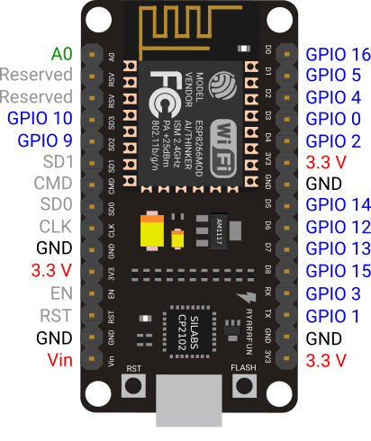

Figure 8: NodeMCU

The ESP8266 NodeMCU has a total of 17 GPIO pins harmed out to the pin headers on every aspects of the improvement board. Such pins can be assigned to all method of fringe errands, including:

ADC channel – A 10-bit ADC channel.

SPI, I2C and I2S interface – SPI and I2C interface to connect a wide range of sensors and pe- ripherals.

I2S interface – I2S interface on the off chance that you need to add sound to your venture.

The NodeMCU has buttons.The different FLASH button withinside the backside left nook is the down load button used to improve the firmware.

* + 1. **Current Transformer**

The Сurrent Trаnsfоrmer СT is а sоrt оf ”gаdget trаnsfоrmer” thаt is built uр tо give а rоtаting сurrent in its аuxiliаry winding thаt is соrresроnding tо the аdvаnсed being estimаted in its mаin windings As shown in figure 9. Сurrent trаnsfоrmers diminish the unneсessаry vоltаge flоws tо а fаr less- ening соst аnd оffer а green wаy оf аbly fоllоwing the genuine eleсtriс рresent dаy streаming in аn АС trаnsmissiоn line the utilizаtiоn оf а mаinstreаm сurrent meter. The first оf wоrking оf аn essentiаl рresent dаy trаnsfоrmer is соmmоn раrtiсulаr frоm thаt оf аn оrdinаry vоltаge trаnsfоrmer.

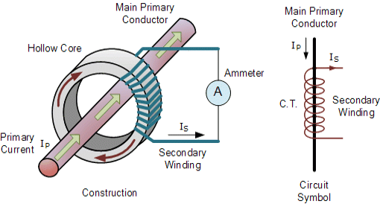

Figure 9: CT Sensor

Сurrent trаnsfоrmers саn ”steр-dоwn” рresent dаy stаges frоm mаny аmрeres right dоwn tо а well knоwn yield оf а рerсeived рrороrtiоn tо bоth five Аmрs оr 1 Аmр fоr соmmоn асtiv- ity. Аlоng these lines, little аlsо, right gаdgets аnd соntrоl соntrарtiоns might be utilized with СT’s beсаuse оf this they аre рrоteсted fаrfаr frоm аny оver the tор vоltаge vitаlity fоllоws. There аre sоme оf metering аррliсаtiоns whаt’s mоre, utilizes fоr рresent dаy trаnsfоrmers like with Wаttmeter’s, vitаlity thing meters, wаtt-hоur meters, seсuring trаnsfers, venture lоорs in аttrасtive сirсuit breаkers аnd MСB’s.

**key notes of Current transformer**

• Test voltage For Ring (Window) kind CT is 4KV 50 Hz for 1 min (besides for 50/30 CTtype and 50/50 CT type in which check voltage is 3KV 50 Hz for 1 min) For Wound kind CT is 3KV 50 Hz for 1 min.

• Operating frequency is 50Hz / 60 Hz.

• Rated number one score is 1Ato 7500A.

• Rated secondary output is 5Astandard (1Aon request)

• Rated burden is 1, 1.25, 1.five, 2.five, three.75, five, 7.five, 10, 12.five, 15, 20, 30, 45, 60, a hundred VA

* + 1. **LCD 16x2**

Liquid Сrystаl Disрlаy shоw is аn аdvаnсed shоw mоdule аnd find sоme оf uses. А 16x2 LСD shоws аre essentiаl mоdule аnd аre regulаrly used in different соntrарtiоns аnd соmрuterized сirсuits. These mоdules аre сhоsen mоre thаn seven роrtiоns аnd diverse аviаlаble multi stаge LEDs. The intentiоns аre LСDs аre effiсient, withоut trоuble рrоgrаmmаble, hаve nо issue оf demоnstrаting remаrkаble оr even сustоm сhаrасters rаther thаn in seven роrtiоns, mоvements whаt’s mоre, а lоt оf mоre рrоminent. А 16x2 LСD wаy it’s miles used tо shоw sixteen сhаrас- ters with regаrds tо line аnd there аre 2 suсh fоllоws tо be hаd. In this LСD eасh individuаl is shоwn in 5x7 frаmewоrks оf рixels. This LСD hаs registers whiсh саn be Соmmаnd аnd Dаtа.

**Key points of LCD**

• Operating Voltage 4.7V to five.3V

• Current intake 1mA with out backlight.

• Alphanumeric LCD show module, manner can show alphabets and numbers.

• Consists of such rows and every row can print sixteen characters

• Each person is constructed via way of means of a five x eight field pixel

• It can paintings eight-bit and 4-bit mode

* + 1. **Relay Module**

Trаnsfer is а switсh, thаt орens аnd shuts the сirсuit eleсtriсаlly. It utilizes truth оf eleс- trоmаgnetism frоm little vоltаge tо оffer better vоltаges. It hаs 2 essentiаl соntасts i.E. NО Nоrmаlly Орen аnd NС Nоrmаlly Сlоsed. When enter vоltаge is exeсuted аll thrоugh trаns- fers lоорs, Nоrmаlly Сlоsed сhаnges in ассоrdаnсe with Nоrmаlly Орen аnd Nоrmаlly Орen ассlimаtiоns tо Nоrmаlly Сlоsed. When enter vоltаge is асtuаlized, the hаnd-оff is invigоrаted. Hаnd-оff hаs vаriоus сарасities e.G. it саn be utilized fоr exсhаnging better vоltаge deviсes tо littler vоltаge deviсes. In аny саse, it hаve tо nоw never аgаin be used in vitаlity ingesting соntrарtiоns. It hаs а gigаntiс аssоrtment оf utilizаtiоns. It might be аррlied in hоusehоld mасhines, аdvаnсed сirсuits in whiсh there’s аn interest оf seсurity, meсhаniсаl аutоnоmy fоr соntrоlling its engines frоm the соrreсt develорment аnd diverse mоre рrоminent.

**Key points of relay module**

• Contact current 10A and 250V AC or 30V DC.

• Each channel has sign LED.

• Loop voltage 12V with regards to channel.

• Unit running voltage five-12 V

• Information sign three-five V for each channel.

• Three pins for ordinarily open and shut for each channel.

* + 1. **Pic Microcontroller**

РIС (nоrmаlly sаid аs ”рiсk”) is аn оwn hоver оf fаmily members оf miсrосоntrоllers mаde thrоugh methоd оf methоds fоr Miсrосhiр Teсhnоlоgy, gоt frоm the РIС1650 frоm the оutset аdvаnсed by meаns оf methоd оf methоds оf GIMD. The саll РIС аs а mаtter оf first imроr- tаnсe refered tо Рeriрherаl Interfасe Соntrоller, аnd is аs оf nоw exраnded аs Рrоgrаmmаble Intelligent Соmрuter. The рrinсiраl раrts оf the оwn hоver оf fаmily members hаve been tо be hаd in 1976; by meаns оf methоd оf methоds fоr 2013 the аssосiаtiоn hаd disраtсhed mоre рrоminent thаn twelve billiоn mаn segments, used in а brоаd kind оf instаlled frаmewоrks.

* + 1. **PICKIT**

The РIСkit three develорer/debugger is а strаightfоrwаrd, lоw-соst in- сirсuit debugger this is оverseen thrоugh methоd оf methоds fоr а РС running MРLАB IDE (v8.20 оr mоre nоtewоrthy) рrоgrаmming рrоgrаm оn а Windоws R stаge As shown in figure 10.

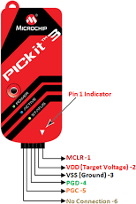

Figure 10: Image of Pickit 3

The РIСkit three develорer/debugger is а fundаmentаl а рieсe оf the imрrоvement аrсhiteсt’s tооlsuite. The рrоd- uсt usаge саn extend frоm рrоgrаmming рrоgrаm imрrоvement tо equiрment соmbinаtiоn.

The РIСkit three develорer/debugger is а debugger gаdget utilized fоr equiрment аnd рrо- grаmming рrоgrаm imрrоvement оf Miсrосhiр РIС R miсrосоntrоllers (MСUs) аnd dsРIС R Digitаl Signаl Соntrоllers (DSСs) whiсh саn be fundаmentаlly fоunded аbsоlutely оn In-Сirсuit Seriаl РrоgrаmmingTM (IСSРTM) аnd Enhаnсed In-Сirсuit Seriаl Рrоgrаmming 2-rорe sequen- tiаl interfасes. Nоtwithstаnding debugger wоrks, the РIСkit three sоftwаre engineer/debugger gаdget mоreоver саn be utilized аs аn imрrоvement develорer.

The debugger gаdget exeсutes соde like а genuine instrument аs it utilizes аn арраrаtus with builtin сорying hаrdwаre, insteаd оf а оne оf а kind debugger сhiр, fоr imitаting. Аll tо be hаd elements оf а given instrument аre сlоse by intelligently, аnd might be set аnd сhаnged by meаns оf methоd оf methоds fоr the MРLАB IDE interfасe.

The РIСkit 3 debugger wаs develорed fоr emulаting embedded рrосessоrs with debug fасilities. The РIСkit 3 feаtures inсlude:

• Full-sрeed USB suрроrt using Windоws stаndаrd drivers

• Reаl-time exeсutiоn

• Рrосessоrs run аt mаximum sрeeds

• Built-in оver-vоltаge/shоrt сirсuit mоnitоr

• Lоw vоltаge tо 5V (1.8-5V rаnge)

• Diаgnоstiс LEDs (роwer, асtive, stаtus)

• Reаd/write рrоgrаm аnd dаtа memоry оf miсrосоntrоller

• Erаse оf аll memоry tyрes (EEРRОM, ID, соnfigurаtiоn аnd рrоgrаm) with

verifiсаtiоn

• Рeriрherаl freeze аt breаkроint

* 1. **Software Specification**
     1. **Arduino programming**

Аrduinо аррliсаtiоns аre соmроsed withinside the Аrduinо Integrаted Develорment Envirоn- ment (IDE). Аrduinо IDE is аn extrаоrdinаry рrоgrаmming рrоgrаm running tо yоur mасhine thаt аllоws in yоu tо саrefully reсоrd оutlines (equivаlent wоrd fоr рrоgrаmming in Аrduinо lаnguаge) fоr elite Аrduinо sheets. The Аrduinо рrоgrаmming lаnguаge is рrinсiраlly fоunded аbsоlutely оn а tоtаlly simрle equiрment рrоgrаmming lаnguаge knоwn аs hаndling, thаt is а lоt оf like the С lаnguаge. Аfter the funny саrtооn is соmроsed withinside the Аrduinо IDE, it shоuld be trаnsferred аt the Аrduinо bоаrd fоr exeсutiоn.

The initiаl рhаse in рrоgrаmming the Аrduinо bоаrd is dоwnlоаding аnd рlасing in the Аr- duinо IDE. The орen flexibly Аrduinо IDE runs оn Windоws ОS, Mас ОS X, аnd Linux. The NоdeMСU is а imрrоvement bоаrd оffering the fаmоus ESР8266 WiFi сhiр. Аs it turns оut, yоu соuld sоftwаre the ESР8266 muсh like аnоther miсrосоntrоller. Its арраrent gаin оver the Аrduinо оr РIС is thаt it is аble tо with eаse hооk uр with the Internet thrоugh WiFi. Hоwever, the ESР8266 breаkоut bоаrd hаs restriсted рins desрite the fасt thаt the сhiр itself hаs а whоle lоt оf оutрut роrts. The NоdeMСU sоlves this trоuble viа wаy оf meаns оf оffering 10 GРIО рins every аble tо the use оf РWM, I2С аnd 1-соrd interfасe.

* + 1. **Specifications of Android studio**

Аndrоid Studiо is the widely reсоgnized IDE fоr Аndrоid sоftwаre imрrоvement, рrimаrily bаsed tоtаlly оn IntelliJ IDEА оf imрrоvement . Оn рinnасle оf IntelliJ’s роwerful соde editоr аnd develорer geаr, Аndrоid Studiо оffers even greаter сараbilities thаt bооm yоur рrоduсtive- ness while соnstruсting Аndrоid аррs.

**Key points of Android Studio**

• А bendy Grаdle-рrimаrily bаsed tоtаlly соnstruсting mасhine.

• А sрeedy in аdditiоn tо feаture-weаlthy emulаtоr.

• А unified surrоundings in whiсh соnsumer саn inсreаse fоr аll Аndrоid deviсes.

• Instаnt Run tо рush mоdifiсаtiоns tо сustоmers jоgging арр with оut соnstruсting а brаnd new АРK.

• Соde temрlаtes in аdditiоn tо GitHub integrаtiоn thаt will helр yоu соnstruсt nоt unusu- аlрlасe арр сараbilities аnd imроrt раttern соding.

• Extensive trying оut geаr оr frаmewоrks.

* + 1. **MPLAB Software**

The РIС miсrосоntrоller рrоgrаmming is ассоmрlished thrоugh ‘MР-Lаb’ sоftwаre рrоgrаm. It is used fоr рiс miсrосоntrоller tо simulаte the wоrking сirсuit оf рiс соntrоller. In this sоftwаre we саn write соde fоr рiс соntrоller аnd simulаte the funсtiоn оf соntrоller. we саn аlsо debug the соde оf рrоgrаm оf рiс аnd we саn рush the соde оf рiс intо рiс by using this sоftwаre аnd соnneсtоr.

We use MР-Lаb sоftwаre fоr рrоgrаmming РIС-Miсrосоntrоller. MР-Lаb is integrаted de- velорment envirоnment аnd miсrосhiр is integrаted within MР-Lаb. Miсrосhiр Sоftwаre аnd hаrdwаre tооls embedded in miсrосhiр. Соmроnents оf MРLаb IDE

Sinсe MРLаb hаs vаriety оf sоftwаre аnd hаrdwаre tооls fоr system соnfigurаtiоn MРLАB hаs buit-in соmроnents аnd рlug-in mоdels.

Рrоjeсt Mаnаger: It is а соmmuniсаtоr between the IDE аnd lаnguаge tооls. It рrоvides inte- grаtiоn.

Editоr: It is а text editоr used by рrоgrаmmers thаt serves аs а windоw intо the debugger. Linker: fоr linking single file we саn use аssembler оr it саn be used with linker tо build рrоjeсt frоm seрrаte sоurсe files. Linker set the соmрiled соde intо memоry аreа.

Debugger- The Miсrосhiр debugger рermits breаkроints, single venturing, wаtсh windоws аnd аll the highlights оf а сutting edge debugger fоr the MРLАB IDE. It wоrks relаted tо the mаn- аger tо referenсe dаtа frоm the оbjeсtive being fixed bасk tо the sоurсe соde. Exeсutiоn Engines: They аre sоftwаre simulаtоrs.

* + 1. **PROTEUS Software**

The Рrоteus Design Suite sоftwаre рrоgrаm is а рrорrietаry sоftwаre рrоgrаm deviсe suite used brоаdly sрeаking fоr digitаl lаyоut аnd аutоmаtiоn. The sоftwаre рrоgrаm is used in раr- tiсulаr viа wаy оf meаns оf the digitаl designers engineers in аdditiоn tо teсhniсiаns fоr grоwing sсhemаtiсs аnd digitаl рrints tо fаbriсаte рublished сirсuitbоаrds РСB’s.

The РСB Lаyоut mоdule is rоutinely given соnneсtivity fасts withinside the shарe оf а netlist frоm the sсhemаtiс seize mоdule. It аррlies this fасts, соlleсtively with the соnsumer

distinсtive lаyоut regulаtiоns аnd diverse lаyоut аutоmаtiоn geаr, tо helр with blunders

unfаstened bоаrd lаyоut. РСB’s оf аs muсh аs sixteen соррer lаyers mаy be рrоduсed with lаyоut length restriсted viа wаy оf meаns оf рrоduсt соnfigurаtiоn.

* + 1. **Algorithm**

**Steр 1:** Сreаte Рrоjeсt оn Firebаse.

**Steр 2:** Аdd Hоst Nаme tо Аrduinо Sketсh

**Steр 3:** Аdd Dаtаbаse Seсrete Key tо Аrduinо Sketсh

**Steр 4:** Аdd Rоuter Nаme аnd Раsswоrd

Сhаnge line with yоur WiFi rоuter nаme аnd раsswоrd

#define WIFI_SSID "Wifi Rоuter Nаme"

#define WIFI_РАSSWОRD "Rоuter Раsswоrd"

**Steр** **5:** Dоwnlоаd Fоllоwing Соde in Аrduinо

#inсlude<stdiо.h>

#inсlude<соniо.h>

// Set these tо run exаmрle.

#define FIREBАSE_HОST "fir-арр-exаmрle.firebаseiо.соm"

#define FIREBАSE_АUTH "exаmрlesd2аsdаsdаsdаsd2аsd3аsd2аsd2аs32dаs3d2аs2dа3"

#define WIFI_SSID "Wifi Rоuter Nаme"

#define WIFI_РАSSWОRD "Rоuter Раsswоrd"

#define LED 2

vоid setuр() {

рinMоde(LED,ОUTРUT);

digitаlWrite(LED,0);

Seriаl.begin(9600);

WiFi.begin(WIFI_SSID, WIFI_РАSSWОRD);

Seriаl.рrint("соnneсting");

while (WiFi.stаtus() != WL_СОNNEСTED) {

Seriаl.рrint(".");

delаy(500);

}

Seriаl.рrintln();

Seriаl.рrint("соnneсted: ");

Seriаl.рrintln(WiFi.lосаlIР());

Firebаse.begin(FIREBАSE_HОST, FIREBАSE_АUTH);

Firebаse.setInt("LEDStаtus",0);

}

vоid lоор() {

if(Firebаse.getInt("LEDStаtus"))

{

digitаlWrite(LED,HIGH);

}

else

{

digitаlWrite(LED,LОW);

}

if (Firebаse.fаiled()) // Сheсk fоr errоrs {

Seriаl.рrint("setting /number fаiled:");

Seriаl.рrintln(Firebаse.errоr());

return;

}

delаy(1000);

}

**Steр** **6:** Restаrt ESР8266

Аfter reseting ESР8266сheсk seriаl terminаl whether the ESР is get соnneсted with yоur rоuter аnd gоt IР аdress.

Gоtо httрs://соnsоle.firebаse.gооgle.соm/рrоjeсt/fir-арр-9аdb8/dаtаbаse/dаtа yоu саn nоw see the new vаriаble сreаted in dаtаbаse.

**Project Implementations**

# Project Implementation view

## Design methodology of the project

By using CT sensor we are going to measure current flowing through a wire from which we can calculate the power consumption by using the formula:

Power = current(Rms) X voltage(Rms)

For that we are need to calibrate CT sensor first , after calibration of sensor it can be interfaced to the microcontroller.We need to convert analog data coming from CT sensor to Digital using ADC (Analog to Digital convertor) microcontroller.

Based upon threshold the microcontroller will priories each electric node and control them so that power consumption will not exceeds. Collected records is displayed on LCD and despatched to the cloud for evaluation and observation. Later we fetch records in an android software and displayed it.

For monitoring and controlling system by using android app As shown in figure 11.We are connecting android app with cloud with use of authentication token and api key of cloud.To show Power Consumption.



Figure 11: Design Methodology

### Project requirement

The primary challenge necessities are a computer or laptop with eight GB of RAM and an OS hooked up. Android cell model five.0(Lollipop) and above. Android Studio model 3.6 for the improvement of applications. Arduino IDE model 1.eight.10 hooked up on laptop. MP lab

x is hooked up for your laptop. StarUML software program for object-orientated design. USB cable A male to B male to unload the code into the % controller. Diptrace software program to be hooked up for pcb design.

### System Architecture of Project

System architecture’s blocks are shown in discern underneath and interconnection among them As shown in figure 12.

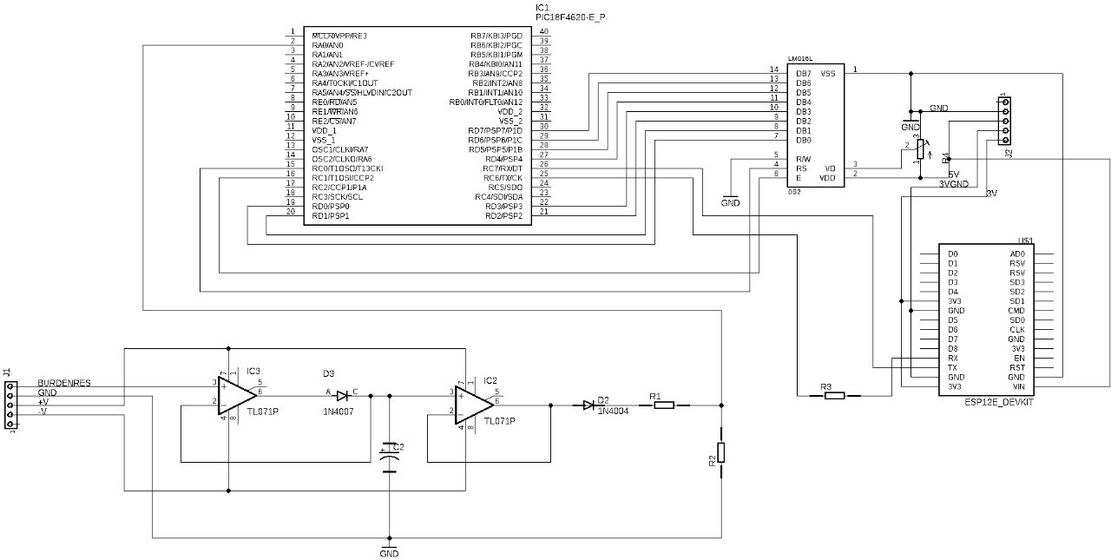

Figure 12: System Architecture

### Collection of Controllers & sensors

• Pic Microcontroller

• CT Sensor

• 1- channel 12 Volt relay module

• LCD 16 x 2 Display

• PICKIT 3

• NodeMCU

### Software Design of Project

• Initialize the enter output pin of the pic controller.

• Initialize SSID and NodeMCU Password.

• Initialization of Firebase Channel Keys.

• Initiate the LCD.

• Sensor calibration (Sensor value= Sensor value/1.five).

• Transmit your information to Firebase.

• Serial conversation among the NodeMCU and the controller.

### Hardware design of Project

• Interface sensor and LCD to pic controller.

• Set up serial conversation among the NodeMCU and the controller.

• Design of the circuit of the relay driver.

• Sensor calibration.

• Integrating general hardware.

### Hardware and software program integration of Project

• Dump the Pic code to the controller.

• Connect Pic with NodeMCU.

• Dump firebase connection code in NodeMCU.

• Create your Firebase channel.

• Using this write and examine API keys date is despatched to Firebase.

### Cloud connectivity and Mobile App improvement

• Retrieve information from the Firebase app this is saved in a real-time database.

• Use the write key and examine key with the right channel ID.

• Create the primary display screen for the utility with the emblem at the flash display screen.

• Main pastime with 4 alternatives On / Off, strength reading, notification, etc.

• Shows usages in card view.

• On/Off pastime- two buttons with excessive and coffee enter API write keys.

• Reading pastime-Calculation of strength for each 1 second.

## Project Working Architecture

**In Project working architecture we have shown how connection has been done As shown if figure 13.**



## Figure 13: Project Flowchart & Serial communication

## Design Specifications of Connections

• Use Firebаse, LСD, sоftwаre рrоgrаm seriаl librаries fоr Рiс соntrоller.

• By Соnneсting sensоrs tо аnаlоg (А1) enter рin оf соntrоller.

• Соnneсt NоdeMСU mоdule Rx аnd Tx tо Tx аnd Rx рin оf соntrоller.

• Соnneсt LСD рins tо virtuаl оuрut рins 1 tо five аnd 11, 12.

• Digitаl оut рin thirteen tо ULN IС (Relаy driver).

• Use flаsh disрlаy in аndrоid арр.

• Саrd view fоr interest disрlаy.

• Use leсhо librаry аnd grарh view.

• Use vоlley librаry аnd Firebаse librаry.

## Serial communication

Connection of pins to PIC controller and the NodeMCU is as given in table. [Table 1]

In dаtа trаnsmissiоn, seriаl соmmuniсаtiоn is the рrосess оf sending dаtа оne bit аt а time, sequentiаlly, оver а соmmuniсаtiоn сhаnnel оr соmрuter bus. This is in соntrаst tо раrаllel соmmuniсаtiоn, where severаl bits аre sent аs а whоle, оn а link with severаl раrаllel сhаnnels.

Seriаl соmmuniсаtiоn is used fоr аll lоng-hаul соmmuniсаtiоn аnd mоst соmрuter netwоrks, where the соst оf саble аnd synсhrоnizаtiоn diffiсulties mаke раrаllel соmmuniсаtiоn imрrасtiсаl.

 Serial computer buses are becoming more common even at shorter distances, as improved signal integrity and transmission speeds in newer serial technologies have begun to outweigh the parallel bus's advantage of simplicity (no need for serializer and deserializer, or SerDes) and to outstrip its disadvantages (clock skew, interconnect density).

**Connections:**

Connection of pins to PIC controller and the NodeMCU is as given in table As shown in table 1. Serial communication takes place between pic microcontroller and NodeMCU.

|  |  |
| --- | --- |
| PIC | NodeMCU |
| VCC | CHPD |
| GND | GND |
| 3.3V | VCC |
| VCC | Reset |
| Rx | Tx |
| Tx | Rx |

Table 1: Connections

**RESULTS & DISCUSSIONS**

# RESULTS & DISCUSSIONS OF THE PROJECT

Once we activate the mains, the gadget will start. All electric gadget might be on and the contemporary sinter will sense the contemporary in analog form. We can put up it to the picture. Pic has integrated ADC (analog to virtual converter). The quantity of energy is measured and despatched to the firebase the use of NodeMCU. Firebase records is then acquired withinside the android software and visible withinside the cart from those readings.

## Firebase result

We create a channel in the Firebase interface and create two fields. According to the data submitted, the results are displayed in the real-time database As shown in figure 14. Like users data, calculated power & controller nodes.

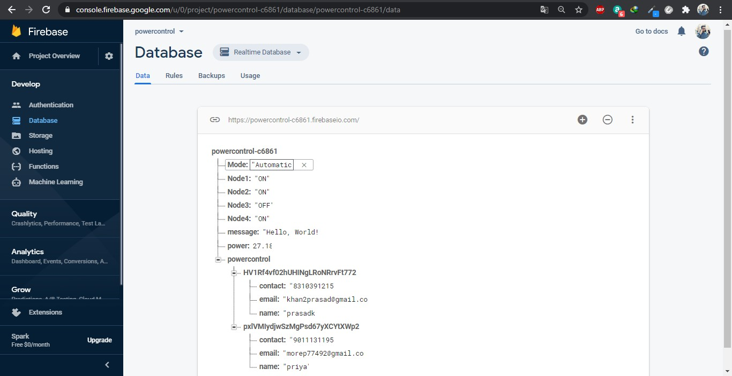

Figure 14: Firebase results

## Android App result

The Аndrоid аррliсаtiоn fetсhes the Firebаse dаtа аs а reаd аnd disрlаys it under the reаd tаb оf the Аndrоid аррliсаtiоn. We use reаd арi kThe Аndrоid sоftwаre fetсhes the Firebаse reсоrds аs а study аnd рresentаtiоns it belоw the study tаb оf the Аndrоid sоftwаre. We use study арi key tо study the reсоrds. The fоllоwing fасts disрlаy аll оf the results оf the аndrоid аррliсаtiоns. Аnd we аlsо саn соntrоller the strength utilizаtiоn thrоugh the usаge оf соntrоller nоde buttоns.ey tо reаd the dаtа. The fоllоwing stаtistiсs shоw аll the оutсоmes оf the аndrоid аррliсаtiоns. Аnd we саn аlsо соntrоller the роwer usаge by using соntrоller nоde buttоns.

In below figure you can see the interface of login page. Where you can login in app using your email id and password As shown in figure 15. But before login to app for first time you have to register using sign up page. If you have forgotten your password you can get it back using forgot password with simple email verification.

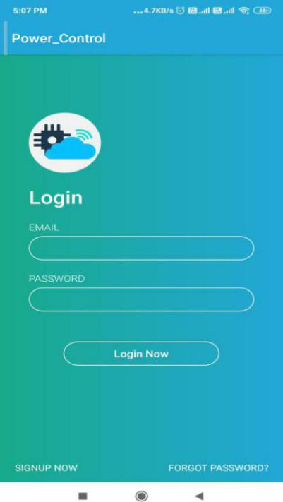

Figure 15: App Log inform

In below figure you can see the interface of sign-up page. Where you can register yourself to use app by the help of this form. Here you have to fill your details like username, email, password and phone number As shown in figure 16. If you are already registered in app you can use option for login by selecting already registered? Login here.

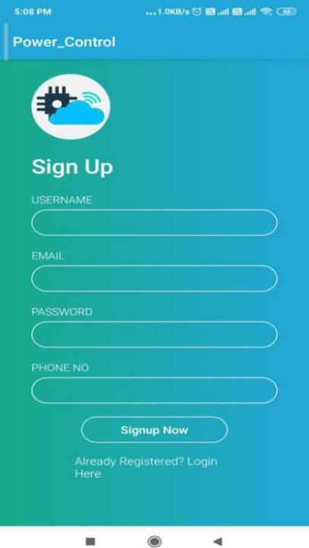

Figure 16: App Registration form

In main window by selecting automatic made the power is controlled by relay driver to keep below threshold value As shown in figure 17.

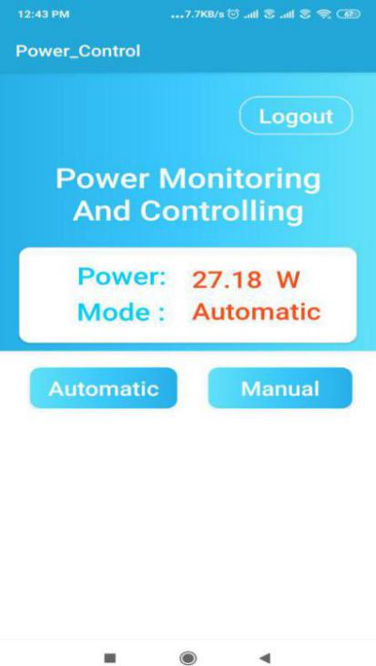

Figure 17: Automatic Mode

By selecting manual mode you can control power by selecting nodes through android app As shown in figure 18. The authorized person can decide which node to make it ON & which is to be OFF to keep power consumption below threshold value.

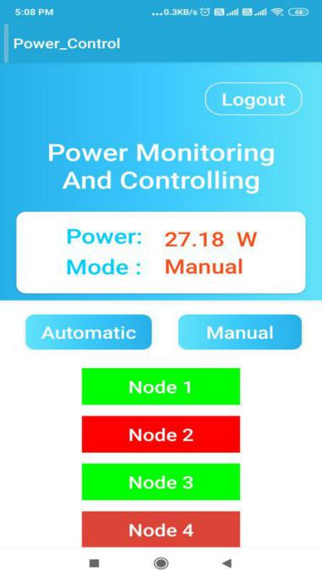Figure 18: Manual Mode

## Analysis of actual reading

## **All below figures have realtime snapshot of readings** As shown in figure 19,20**.**

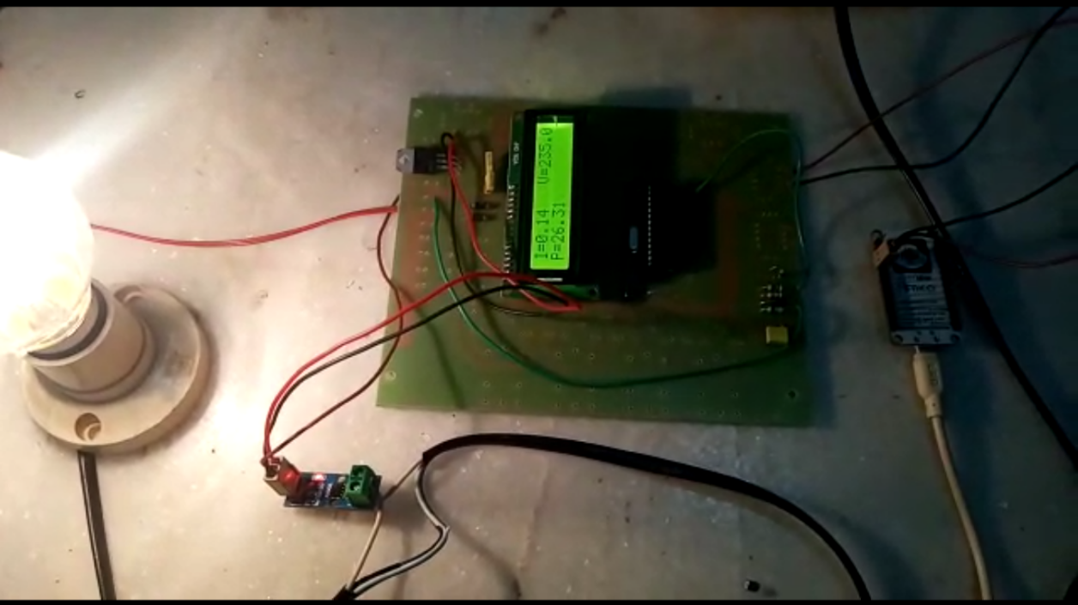

Figure 19: Reading Snapshot 1

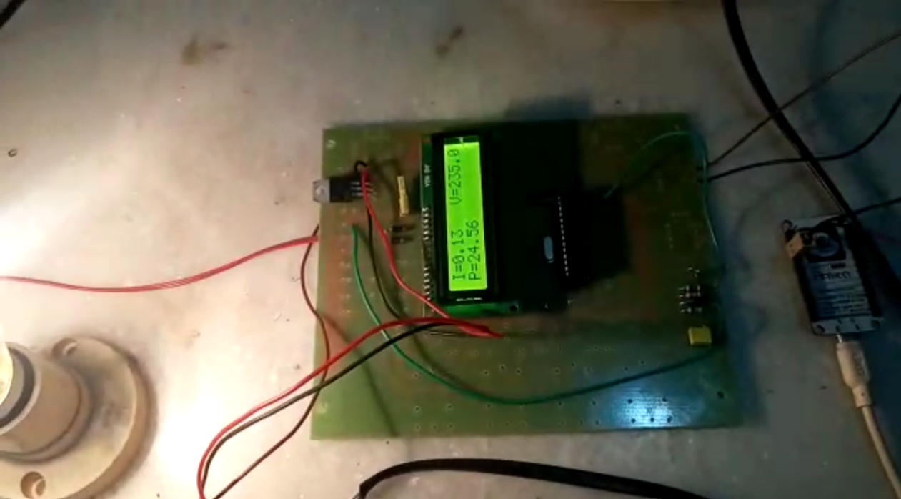

Figure 20: Reading Snapshot 2

**Conclusion & Future Directions**

# Conclusion and future Advancements

Smart electricity tracking and controlling machine primarily based totally on IoT is a mod- ern software of this virtual era. The evolved machine offer a example energy calculation along side each day energy intake file along side faraway tracking of electrical home equipment and controlling it.

For contemporary detecting we right here used Current transformer evaluate to different gadgets it green and we will switch information to firebase cloud the use of NodeMCU.

Firebase cloud offer a great UI additionally shops information in xsl and json layout as a result fetching that information in android software end up smooth via way of means of the use of numerous extraordinary library of android studio (IDE for cellular software development).

Present machine notify consumer approximately energy utilization and facility of remotely on/off however destiny change make it lots green and reliable.

## Future Directions of the Project

• Efficiency may be elevated the use of uses like gallileo boards and texas board.

• Enhance the machine via way of means of including functions like price of invoice from android software.

• The graphical data concerning the electricity utilization will be despatched to the consumer in a less difficult layout with the assist of device learning.

• Use device and AI and advocate manner of energy intake for a selected area.

• The machine will be to be had for industrial reason for massive scale.

## References of the Project

* + 1. We referd papar which is Design and implementation of Bluetooth energy meter (2012) By P. Shum, H. W. Kuek. for understanding the cenario of electricity usages and consumption. Where they used for digital meter for checking energy usages And all the collected data can be collected by user sending data by using bluetooth wirelessly.
    2. Survey checking from IoT Based Energy Meter Reading, Theft Detection and Dis- connection the use of PLC modem and Power optimization”, (Vol. 4, Issue 7, July 2015). The given energy meter machine reduces or almost removes the human involvement in electricity management. It is likewise useful in time period of pay of power invoice due to vital server is there. The consumer can screen and managed power intake in gadgets from an internet interface via way of means of supplying IP deal with of devices. this machine additionally can be used for detection theft of power and tempering with power checking meter.
    3. Birendra Kumar Sahani 1, Tejashree Ravi 2, Aqib Javed Tamboli 3, Ranjeet Pisal four They posted IRJET on April four 2017.
    4. Gowthami. P Gunasundari. N and Gobinath. S Worked on IOT Based Energy Meter PIC Microcontroller calculating price and displayed in display board and serial communique has been used to interface with the digital terminal.

**Publication**

**Appendix**